Name: Ritesh Pawar

Batch: B4

Subject: CNS Lab

PRN: 2020BTECS00068

**Aim: Implementation of RSA algorithm.**

**Theory:**

The RSA algorithm is an asymmetric cryptography algorithm; this means that it uses a public key and a private key (i.e two different, mathematically linked keys). As their names suggest, a public key is shared publicly, while a private key is secret and must not be shared with anyone.

The RSA algorithm ensures that the keys, in the above illustration, are as secure as possible.

**Code:**

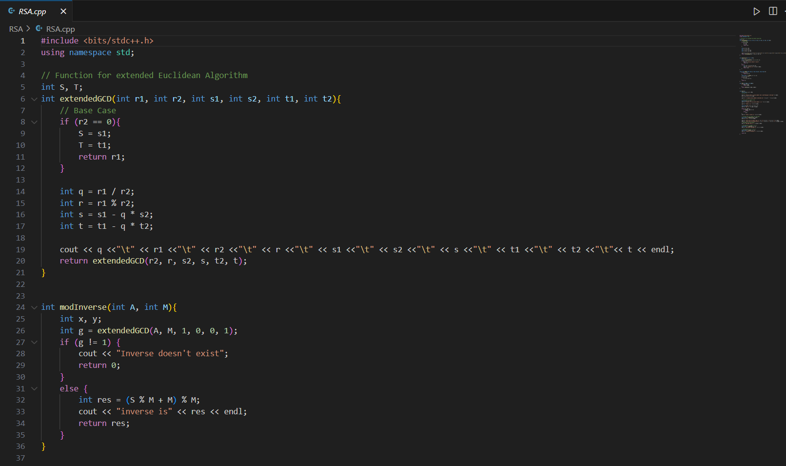

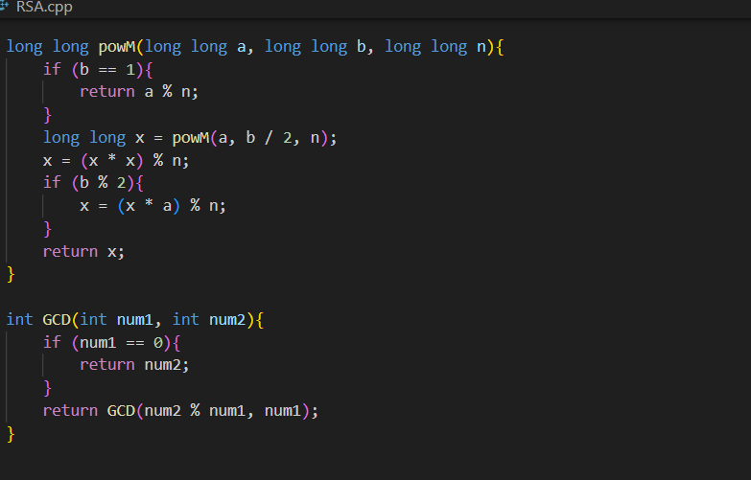

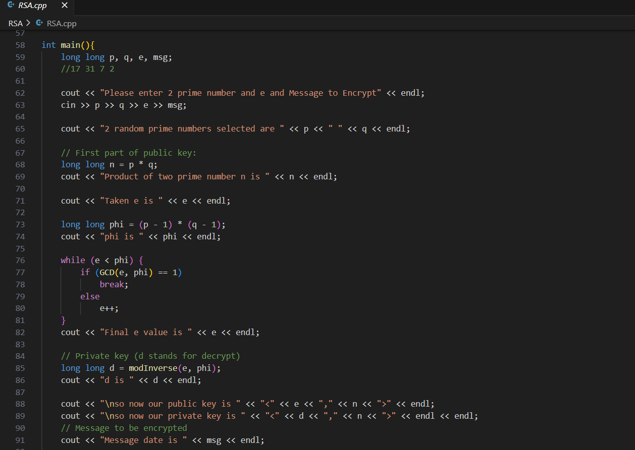

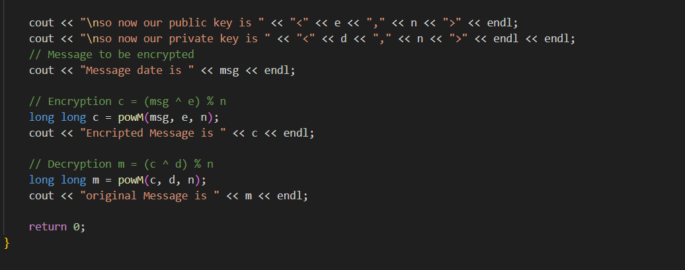

**Output:**

